|  |
| --- |
| Rate-monotonic  Scheduling |

|  |
| --- |
| RTOS – Design |

|  |  |
| --- | --- |
| Hossam Elwahsh  hossam.e.elwahsh@gmail.com |  |



CONTENTS

Rate-monotonic analysis 2

Requirements 2

Calculating Urm 2

Time demand analysis 3  
 Hyperperiod 3

Calculations 3

SimSo Model 4  
 SimSo Results 4

|  |
| --- |
| Rate-monotonic analysis |

|  |  |  |  |  |  |  |  |  |  |  |  |  |  |  |  |  |
| --- | --- | --- | --- | --- | --- | --- | --- | --- | --- | --- | --- | --- | --- | --- | --- | --- |
| Requirements Schedule the following task set using rate-monotonic:   |  |  |  |  | | --- | --- | --- | --- | | Task | Periodicity (ms) | Execution Time (ms) | Deadline (ms) | | T1 | 5 | 2.5 | 5 | | T2 | 15 | 4.5 | 15 | | T3 | 20 | 3.5 | 20 |  Calculating Urm $$U_{rm}= \sum_{i=1}^{n}{\frac{C_{i}}{P_{i}}≤n \left(2^{\frac{1}{n}}-1\right)}$$ $$Where:$$ $$U:total utilization$$ $$C:Execution time$$ $$P:Periodicity$$ $$N:Number of tasks$$ ∴ $U_{rm}=\left(\frac{2.5}{5}+\frac{4.5}{15}+\frac{3.5}{20}\right)≤(3*(2^{\frac{1}{3}}-1))=0.975≤\sim 0.779=False$ ***System needs more tests to verify schedulability as Urm result is false.*** |
| **Hyperperiod $$Hyperperiod=LCM\left(Pi\right)=LCM\left(5,15,20\right)=60ms$$** Calculations |

|  |  |  |  |
| --- | --- | --- | --- |
| Task | Deadline (Tp) | Time needed (Wi) | Schedulable? (Tn <= deadline) |
| T1 | 5 | 2.5 | ✅ |
| T2 | 15 | 12 | ✅ |
| T3 | 20 | 22.5 | ❌ |

## Task 3 is not schedulable

|  |
| --- |
| Time demand analysis |

**SimSo Results**

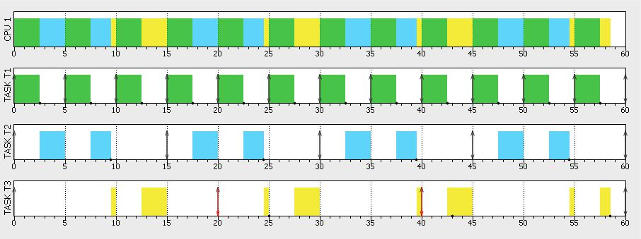

|  |
| --- |
| SimSo Model |

|  |  |
| --- | --- |
| CPU Load | Logs |
|  |  |

*We can clearly notice that task 3 keeps missing its deadline.  
SimSo RM Scheduler model complies with our Urm and Time demand calculations.*